SLOBODANKA TINTOR
IBFF FIT KIDS PRESIDENT

date of birth:  05 July 1979  Place of birth:  Sisak, Croatia  CONTACT:  +385 91 901 3108  www.ibfffitkids.com  www.internationaldanceopen.com  bambiboba@gmail.com  ibff.fitkids@gmail.com  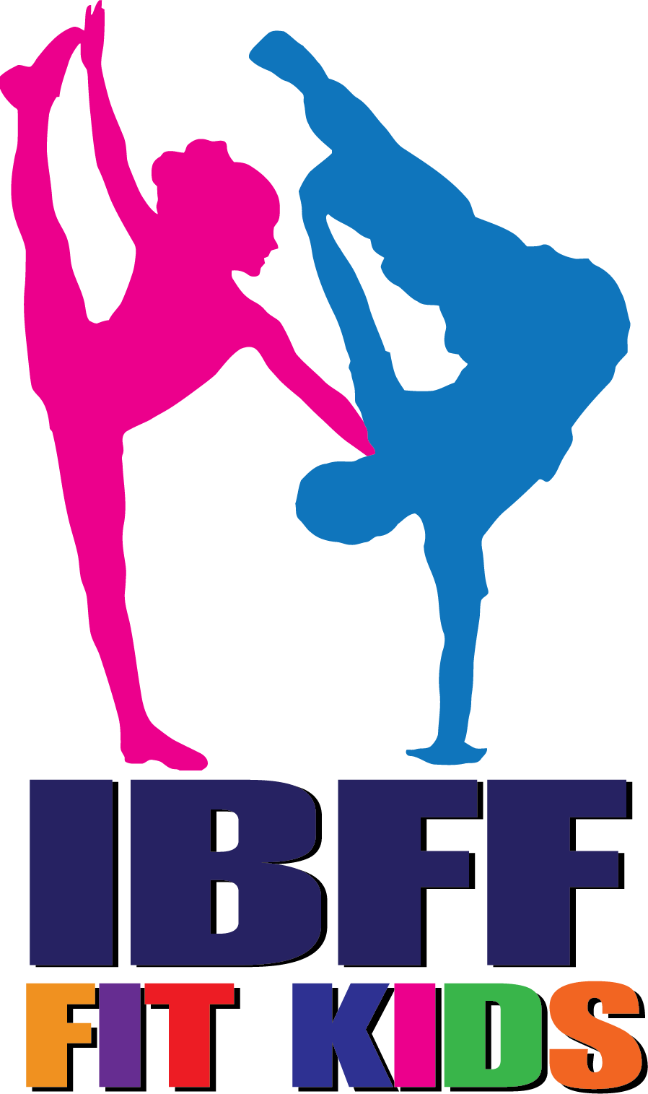 |  | PROFILE  I am the president of IBFF Fit Kids, coach of the Croatian Fit Kids Team, owner of two dance clubs 'Bambi Kids' and 'Dance Academy' in Zagreb. I am also the director and the organizer of International Dance Open – one of the biggest international dance competition and festival.  EXPERIENCE  IBFF Fit Kids President  5 February 2019 - present  Judging  Well known international judge, who has been a part of many big international dance and fitness competitions in Croatia, Italy, Lithuania, Germany, Austria, England, Serbia, Hungary, Romania, etc.  Event organization  Point International Dance Open Zagreb 2015  International Dance Open Zagreb 2016  International Dance Open Zagreb 2017  Winter International Dance Open Zagreb 2017  International Dance Open Zagreb 2018  Fit Kids European Championship Zagreb 2018  World Dance Talents Cup Bergamo – Milano 2018  Winter International Dance Open Zagreb 2018  Grand Prix Vienna 2019  International Dance Open Zagreb 2019  IBFF Fit Kids World Championship Zagreb 2019  International Dance Open Novalja 2019  International Dance Open Budapest 2019  Winter International Dance Open 2019

